In the picture below, a number is being put into the box. Inside the box, something happens to the number, and then a new number is tipped out of the box.
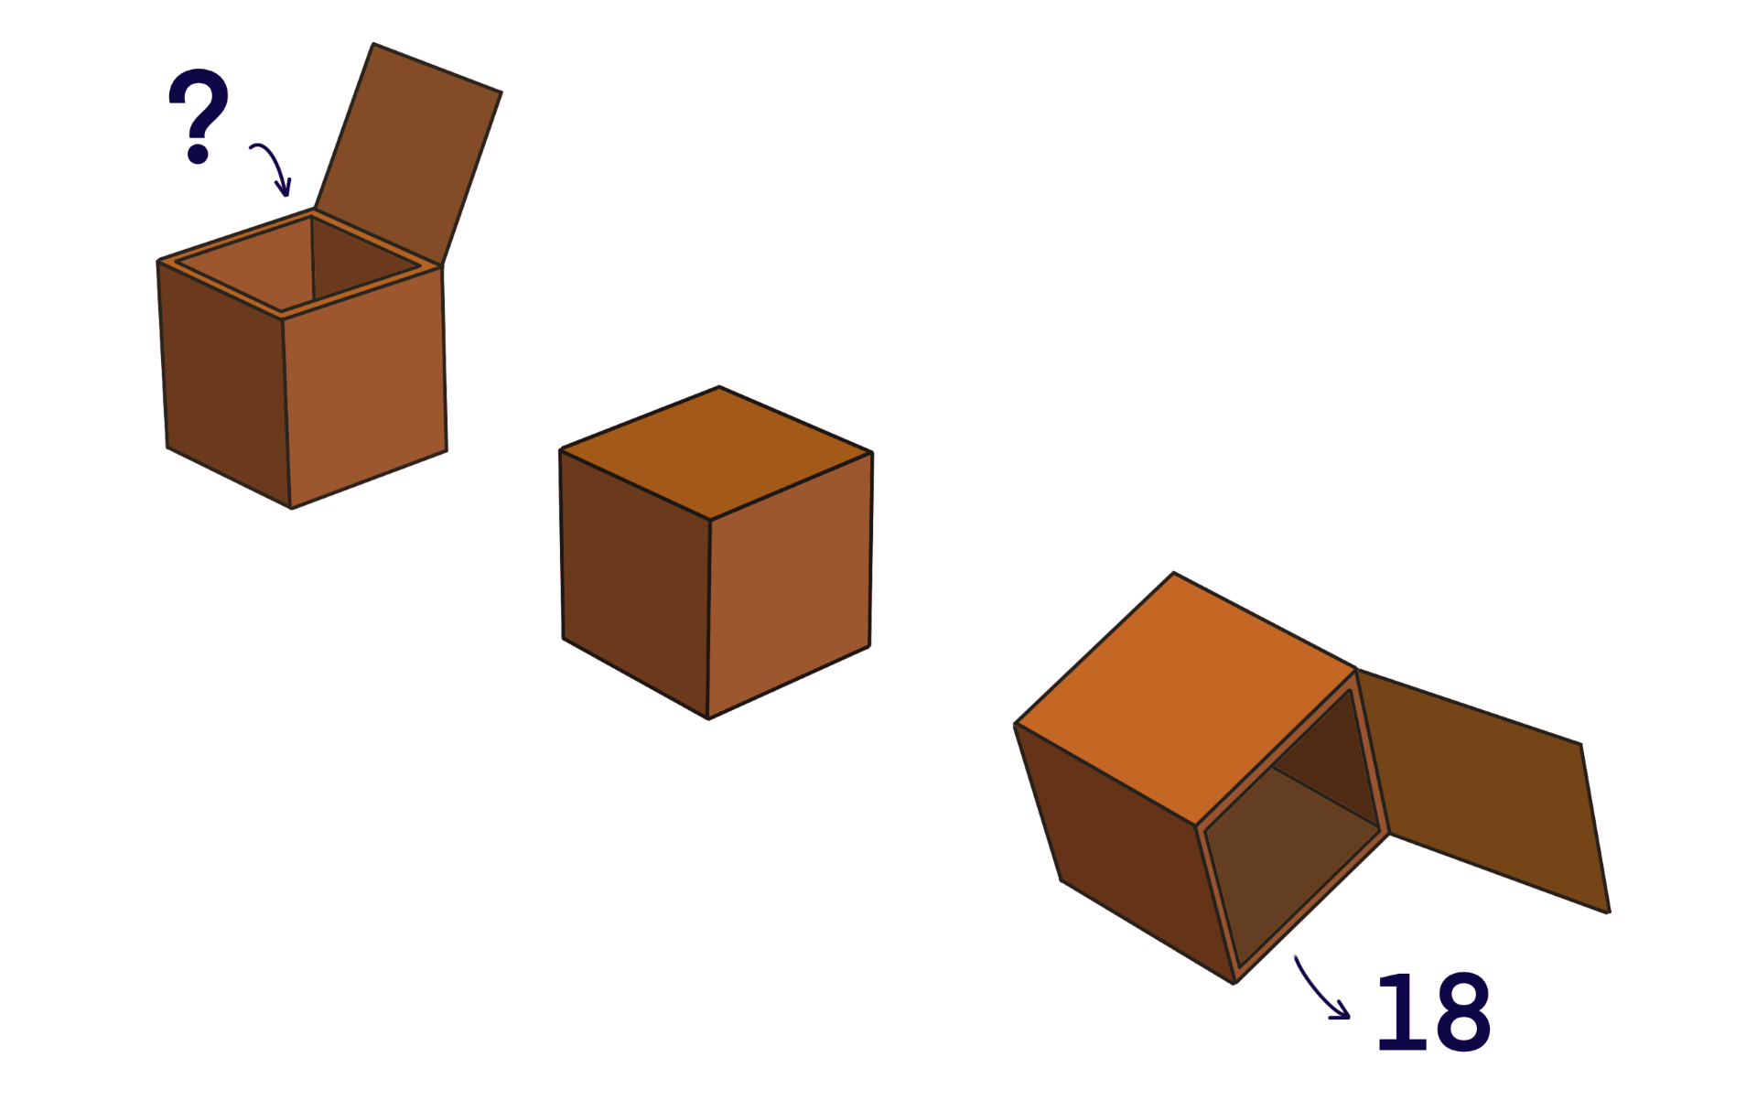
The first time this happens, 10 is put into the box. What happens inside the box to get the number 18?
Now three more numbers go into the box, one at a time. The box does the same thing that it did before, and the numbers that are tipped out of the box are:
12
8
15
What were the three new numbers that went in? Remember that the same thing as before happened to all three of those numbers.
-----------
Next, the box does something different to before. Four new numbers are put into the box, one at a time. One of these numbers is 10 and the rest are secret. Something happens inside the box, and the numbers that are tipped out are:
0
19
1
11
What could have happened inside the box? The same thing has happened to all four numbers that went in.
What could the four numbers have been that went into the box?
Are there any other possibilities? How do you know?

